**Airline Seat Selection, Boarding pass issuance and Aircraft boarding**

**PROJECT**

*19CSE314 – Software Engineering*

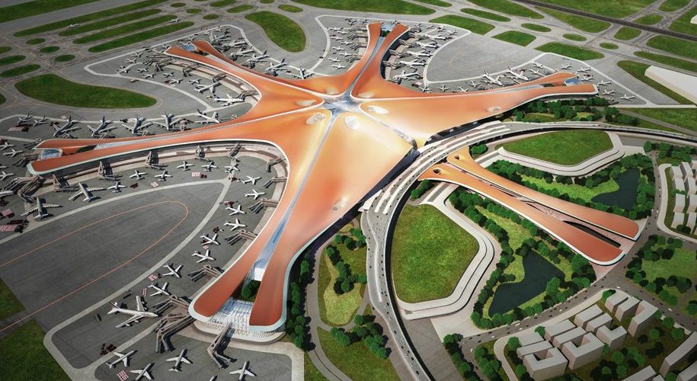

***Date:*** *February 03, 2022*

**Group Details:**

|  |  |  |
| --- | --- | --- |
| S. No | Name of the Student | Roll No. |
| 1. | PENUGONDA KOUSHIK | CB.EN.U4CSE19449 |
| 2. | RAVELLA ABHINAV | CB.EN.U4CSE19453 |
| 3. | ROHIT P M | CB.EN.U4CSE19454 |
| 4. | SINGADI SHANTHAN REDDY | CB.EN.U4CSE19459 |
| 5. | SINGAMANENI LIKHITHA | CB.EN.U4CSE19460 |

**ABSTRACT**

The objective of the project is to design an Airline Reservation System application that enables the passenger to search and book flight tickets which include boarding pass issuance, seat allocation. A reliable and predictable management system with respective operations is essential for aircraft trajectories. The airport management system is an all-in-one application for the complete flight experience, from booking a ticket to seat allocation. The application enables the users to get details regarding the timings of their flight, the boarding date, and also regarding the in-airport amenities such as restaurants, shopping centres, etc. This software has two parts. The first is the user part and the administrator part. The user part is used as a front end and the administrator is the back end. The administrator is used by the airline authority. It will allow the customers to access the database and allow new customers to sign up for online access. The system allows the airline passenger to search for flights that are available between the two travel cities, namely the “Departure city” and “Arrival city” for particular departure and arrival dates. The system displays all the flight’s details such as flight no, name, price and duration of the journey, etc. After searching the system display list of available flights and allows the customer to choose a particular flight. Then the system checks for the availability of seats on the flight. If the seats are available then the system allows the passenger to book a seat. Otherwise, it asks the user to choose another flight. To book a flight the system asks the customer to enter his details such as name, address, city, state, credit card number, and contact number. Then it checks the validity of the card and book the flight and update the airline database and user database. The system also allows the customer to cancel his/her reservation if any problem occurs. The main purpose of this software is to reduce the manual errors involved in the airline reservation process and make it convenient for the customers to book the flights when they require such that they can utilize this software to make reservations, modify reservations or cancel a particular reservation.

For this problem statement we have divided our approach into two parts:

1. How do the airlines decide their operating space (spatial constraint)
2. Evaluate the temporal constraints

The temporal constraint determines:

1. Whether the passenger who joins the queue is able to catch his flight or not.
2. Whether the airline is able to process the passenger within the given time frame so that he is able to catch the flight.

**Goals and Scenarios (In airport)**

1. A proper queuing mechanism should be setup for passengers arriving on time.

* Arriving passengers wait at the lounge till their flight announcement is made.
* Once an announcement is made, passengers join at the end of the queue that leads to the counters for issuance of the boarding pass.
* There is just a single queue. Once a particular counter is free, the next passenger in line gets serviced.

1. Separate Queuing Mechanism for passengers arriving late

* Passengers might typically come later than the initial check-in time suggested. 20 min before the actual flight take-off, an announcement is made to determine the passengers who aren’t yet processed for that flight.
* Care is taken as not to allocate all the counters to such late passengers as it penalizes people arriving on time for the next flight.

1. Flight Announcement should be made at the proper time

* Passengers waiting at the lounge should be given a first call-for picking up ticket issuance 90 minutes before the flight is taken. After that every 30 min a call is given and when just 20 min is left for take-off, a separate mechanism is activated.
* The passengers should join the queue.

1. The service-team size should be of optimal size

* The service team shouldn’t be either in shortage or in excess. A proper trade-off is carried out to determine actual team size at a given time interval.
* Breaks and changes of team members should be done smoothly.

1. A mechanism for passengers missing flight

* If a passenger arrives after the flight has taken off, he has to buy another ticket.
* If a passenger misses the flight because of either connecting flight delay or because of the delay caused by the service team, adequate measures are taken to compensate the passenger and to ensure that he takes the next available flight.

1. The efficiency and effectiveness of the system should be high

* The quality and cost of service provided should be optimal.
* Periodic assessments of the various parameters are to be carried out to ensure that efficiency and effectiveness are maintained at the highest level.
* The system should be highly reliable and feasible.
* The mean service rate should be optimal considering the mean arrival rate of passengers.

1. The service team should have support personnel

* There should be enough support personnel to take care of unprecedented events.
* There should be a maintenance Training/Support Team

1. The system should be capable to withstand active and/or rigorous usage.

* Even when the number of passengers arriving at a particular time exceeds the normal arrival rate, the operations should be carried out efficiently.

**Activities to be done (Interface)**

|  |  |  |
| --- | --- | --- |
| S. No | Screen Name | Description |
| 1. | Login | Allows to login as an administration or a user |
| 2. | Registration | Interface for registering a new member |
| 3. | Online Reservation | Allows user to search flights by specifying journey details and accordingly reserve seats. |
| 4. | Reservation Form | Ask for user details and preferred seat location for booking |
| 5. | Online Transaction | Enables the user to make online payment by providing card details. |
| 6. | Flight Status | Accepts flight details as input and display current status of flight in accordance with them |
| 7. | Web Check-in | Allow to acquire a print of boarding pass by verifying reservation details |
| 8. | Cancel Reservation | Interface which enables the user to cancel reservation by providing e-ticket number |
| 9. | Ancillary Booking | Interface where passenger can choose exact seats, meal type etc. |
| 10. | Baggage handling and reclaim | The airport’s baggage handling system scans these barcodes to sort and track the baggage |

**Tasks:**

1. **Register:**

* Take the data from the user like Name, DOB, Contact Details, Email ID, Gender, Password.

1. **Login:**

* Credentials of the user used while registration
* Forgot password facility

1. **Online Reservation:**

* One-way/Roundtrip
* From place and to place
* Departure date and Return date
* Seat type
* Number of passengers

1. **Reservation Form:**

* Passenger Details
* Covid Vaccination Details
* Seat selection
* Contact details for ticket Status

1. **Online Transaction:**

* Payment modes
* Cancellation and Refund calculation
* Travel Insurance

1. **Flight Status:**

* Flight info
* Runway used
* Arrival and Departure estimation

1. **Web Check-in:**

* Ticket
* ID Proof
* PNR number
* Covid RTPCR report

1. **Cancel Reservation:**

* Cancellation reason
* Cancellation and Refund policy
* Ticket details

1. **Ancillary:**

* Meal Selection
* Seat number
* Separate pets cabin

1. **Baggage handling and reclaim:**

* Luggage tagging
* Code allocation
* Claiming lost luggage

**Initial Use Case Modelling**

1. **Passenger Perspective:**

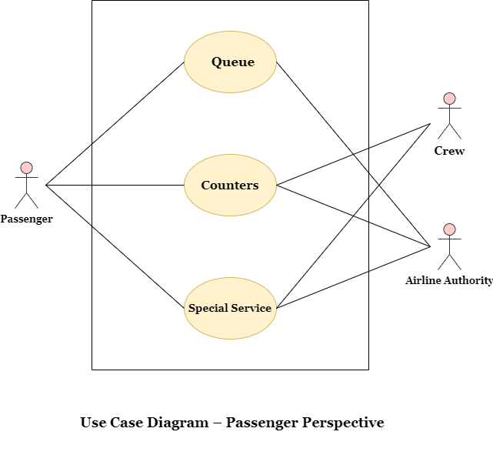

1. **Airline Perspective:**

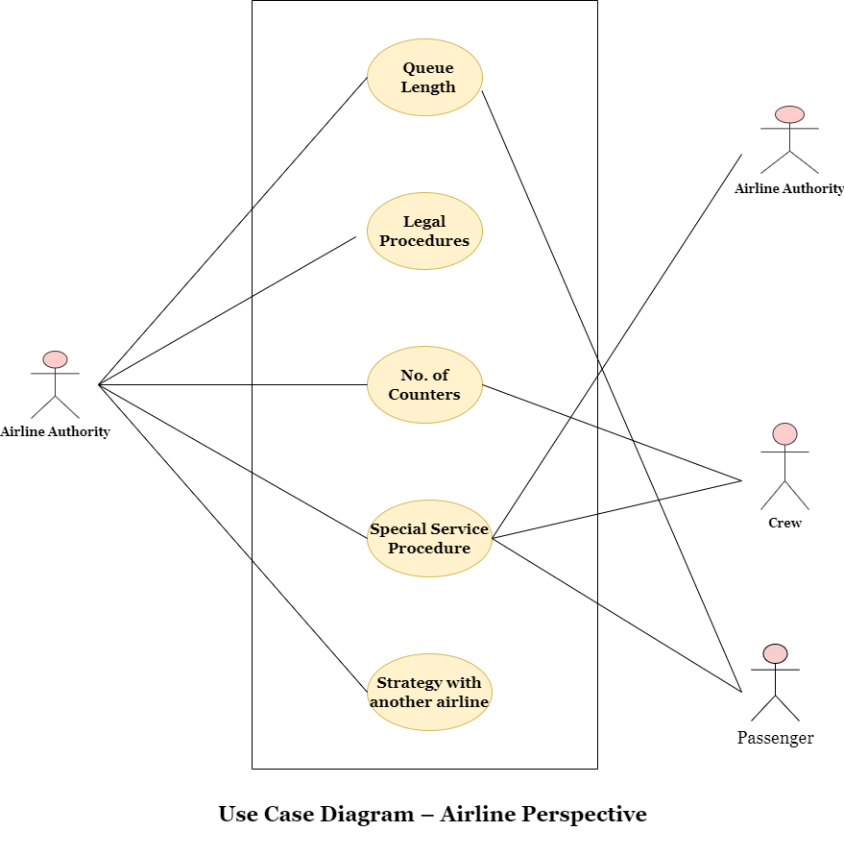

**Epics User Stories Tasks**

1. **Epic: *User account registration and login***

* The First Epic is the “Registration and Login,” and as administrator how you can improve your system security by giving users and services fine-grained access to applications running on EPIC. In other words, make sure each user has only the access they really need and nothing more.
* As a customer, I want to create login credentials so I can securely access my self-service online account.

**User Stories:**

**1.** **Signup successful:**

* If as a user I’m visiting for the first time, then I must register myself.
* A user should fill all the details like username, Email ID, DoB, Phone number, password and confirm password.
* A user should be prompted if username entered already exists in the system - error message "Username taken - please enter another username".
* A user should get a warning if the password and confirm password do not match.
* Password should be of at least 7 characters with 1 number, 1 uppercase letter, 1 lowercase letter, one special character.
* Green check mark next to 'Password' data field should be displayed that indicates to the user after typing password that the entry meets criteria
* Red cross mark next to 'Password' data field should be displayed that indicates to the user after typing password that the entry does not meet criteria.
* All fields are required data fields - error alert should be shown if user clicks on Submit with any of the fields left blank " cannot be empty".

**2.Validation of signup:**

* After a user clicks on a sign-up button then a confirmation email is sent to the email given in the signup form.
* A user has to confirm their email and click on activation link to activate the account.
* After activation, the user is directly logged into the website.

**3. Login successful:**

* If user visit the website, should be asked to login into my account where all my data is stored and secured.
* User should enter their unique username and its matching password.
* While user enter my password It should hidden as type in my password.
* If the username and password match then it should authenticate the account and “Login Successful” should be shown.
* After successful login, the user should be able to enter the website and see their previous activity.
* User want to remember my credentials so that I do not need to enter the credentials every time I login.

**4.Login Failed:**

* If user enter my username incorrect then it should prompt me as “Incorrect username or password”
* If a user enters a password, if the password is incorrect then should prompt as “incorrect password.”
* If a user enters incorrect credentials, then as an administrator I have to reset them so that the user can enter them again.
* Until the user enters the correct credentials the user should not be allowed to login and should be prompted as “Login failed.”

**5.Reset password:**

* If a user wants to reset my password, so that I recover access my account.
* If a user wants to reset their password or forgets their password then there should be place to reset their password.
* On the login page there should be an option, when a user selects that option then as an administrator, I will send a password reset link to the email given by the user during the time of signup.
* User should enter my new password and its confirmation password to reset my password.
* After password reset, as an administrator I should update the old password with the new password.
* After reset, the user should login with new password and username for successful login.

**6. Google/Facebook Login:**

* As a user I want to directly signup/login using my google or Facebook credentials.
* User should select the option then it has to be directed to google account where my website credentials will be same as the google credentials.

**7.Logout:**

* As a user if I want to logout then there should be an option where I come out of the website and my progress is saved.

**8.Update profile:**

* As a user if I want to change my details after signup then there should be a option where I can change my details like username.

**Chart:**

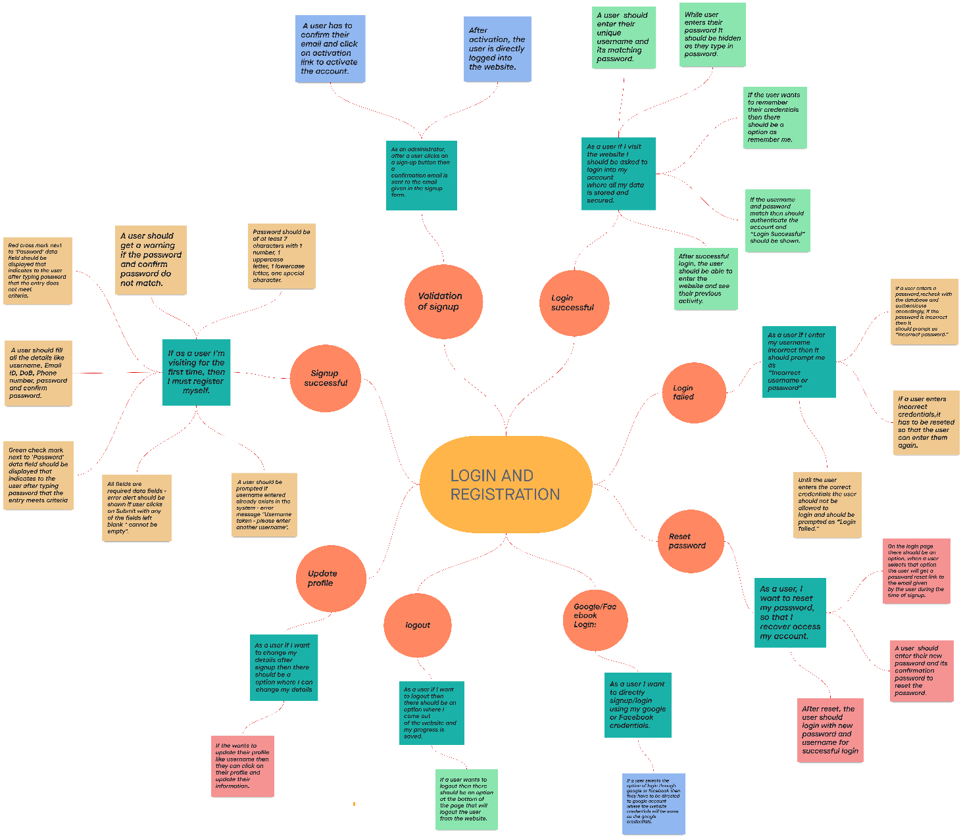

**2. Epic:** ***Discover & Filter***

* The next most important User Epic to be built in this feature is the “Discover & Filter”. This step follows the search feature and is the most important step where the User actually takes a decision to go ahead with a booking.

**User Stories:**

1. As a user, I would like to view flights available for journey on respective date.
   * 1. Create a responsive page using HTML/CSS/JS
     2. Create a search page for finding flights between departure location to arrival location
     3. Add various options like one-way, roundtrip and multi-city.
     4. If user chosen for round-trip, ask for return date
     5. If user chosen for multi-city, ask for cities to be travelled.
     6. Ask for number of passengers.
     7. Also make sure to avail assistance for seniors-citizens, infants.
2. As a User, I would like to view the flights in order of lowest to highest fares, so that i can choose my flight accordingly.
   * 1. Once user is done choosing the locations, create a landing page for filtering the available flights.
     2. Software must be able to show the available flights for desired location
     3. Details of the flight must be visible i.e.,

Service number

Time of departure and arrival time

Cost of journey

* + 1. If user chosen for special assistance for infants, senior-citizens

Flights with this facility should be shown first

* + 1. Also avail discount for senior-citizens above the age of 60 years.

1. As a User, I would like to filter my search results on the basis of Airlines, Departure time and No. of stops, so that I can narrow down my options to pick the best one.
   * 1. Add a navigation bar, which helps in filtering the flights.
     2. Software must be able to show the service number of flight, Airlines company,
     3. Toggle bar for switching between all flights and non-stop flights
     4. Also add the time range between with the flights get departed like 12:00-6:00, 6:00-12:00.
     5. Add the same for the departure
     6. Add time of journey for the chosen flight.
2. As a User, I would like to filter out to view all refundable flights only.
   * 1. Add a filter which shows the specific flights which refunds money on cancellation.
     2. Add the details of refunds according to the time of cancellation
     3. Add a toggle to choose the travel packs
     4. Add various packs like saver, Flexi-plus (Complementary)
     5. Add cancellation terms and conditions.
3. As a User, I would like to filter out to view all non-stop flights only.
   * 1. Add filter to display non-stop flights only.
     2. Add duration of journey
4. As User, I would like to review the flight details after i have selected my choice and before I make the payment, so that I can be sure there have been no errors.
   * 1. Once the user has decided on his flight, it is crucial for him to see an overview of the flight details so he can double check if there are any errors. This will decrease rate of errors and increase customer loyalty.
     2. Once the user is done with the seat selection, total fare should be displayed.
     3. Details of fare break must be included
     4. Security fee, Aviation fee, Passenger service fee must be added to it.
     5. There should be change of going for seat-selection if any issue arises.
     6. Add last cancellation details, refund price
5. As a Stakeholder, we would like to collect passenger details of users booking through "Guest Mode" so that we can establish contact with them in the future.
   * 1. we can allow users to use the “Guest Mode” and have them book their tickets without setting up an account.

**Chart:**

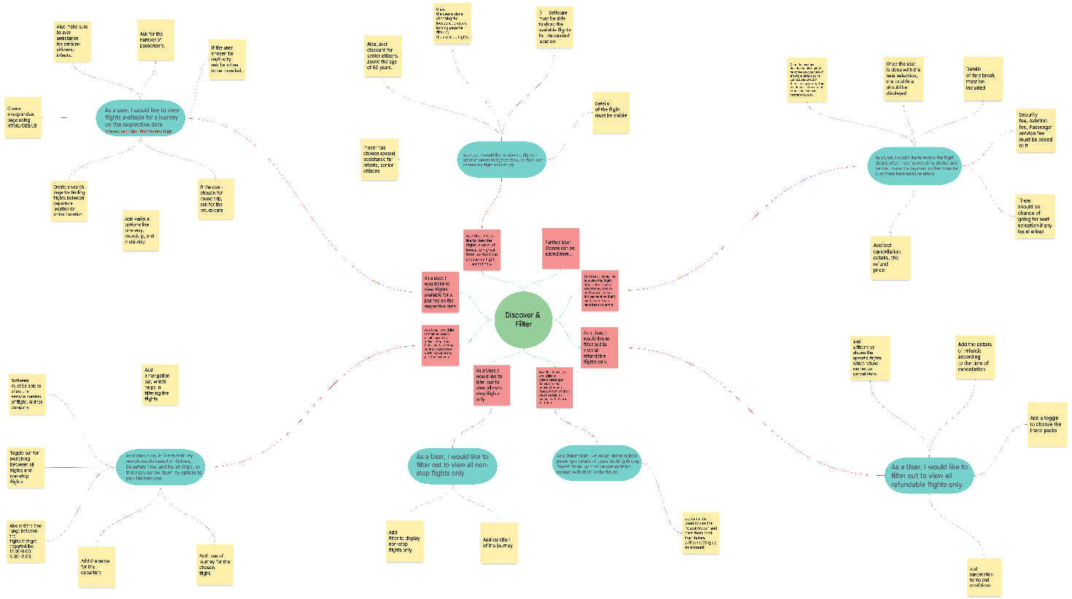

___________________________________________________________________

**3. Epic: *seat selection***

**User Stories:**

1. As a passenger, I would like to select respective class and seat alignment

* Add a page with various classes available
* Add a filter to choose flights based on classes and seat requirement
* Max of seat selection at one time is 5 seats
* Add a feature for senior citizens for special assistance
* Adding an option of modifying the seat after the selection

2.As a user, I would like to receive a confirmation email regarding the seat selection

* Create a software to send mail once the ticket booking is confirmed
* Add a feature to send reminders for passenger till the date
* Send an email to check the flight status
* Sending a mail if flight is cancelled
* Send an email if flight is delayed (in case of connecting flights)

3. As a user, I would like to have an option of continuing to make seat selection/booking in GUEST MODE so that I can book a ticket even without singing in/up

* Adding a function “continue without login in”
* Add a feature where user can explore the software
* Terms and conditions must be accepted
* Guest mode is only enabled for exploring but not for booking
* To book a ticket while in a guest mode, user must create account at payment step
* Adding time constraint in guest mode (say 10 min)

4. As a user I want to have a subtle and easy way online payment after seat selection so that my transaction will happen without hassles

* add a page to view the selected/booked flight details
* passengers contact information to send the details of booked tickets and for further updates
* create a page user can select wide range of payment methods
* add a column where user can redeem the coupons that are applicable
* at the end display the fare break for selected payment methods

Ex: credit/debit

5. As premium member, I would like to have additional benefits

* Adding a feature to view booked seats
* If seats are full, adding a function “Notify me” when seats are available
* If change in plans, add an option to change flights using PNR number
* Adding free special assistance option for benefiting premium members
* Add more comfort, get a blanket, pillow, eyeshade, and dental kit.

**Chart:**

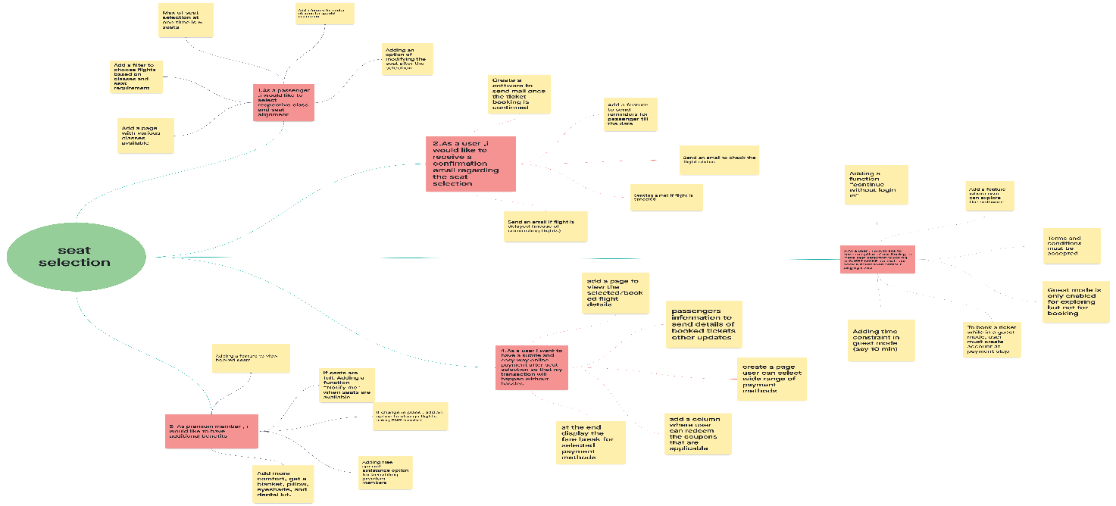

**4.Epic: *Boarding pass issuance***

1.As a passenger, I would like to have add-ons for check-in

* Adding an option for passenger for web check in departure
* Adding free web check-in before the flight departure with time constraint 48 hours to 5 hours
* Adding a fast forward option that Saves time at the airport, check-in first and get your baggage on priority.
* Adding a feature of facilitation fee of ₹200 (domestic flights only) is applicable for airport check-in with assistance.

2.As a user, I need print out of boarding pass

* Add a page where user can get printout of boarding pass using PNR number
* Add a feature user can get PNR number through email
* Adding option to select seat at boarding pass issuance
* In addition to print out add unique QR code
* Dangerous goods are restricted, add an option to declare them in prior

3.As a passenger, I want to De-Check-in if I decide not to travel

* De-Check-In can be done only at the respective Airport by the airline staff

**Chart:**

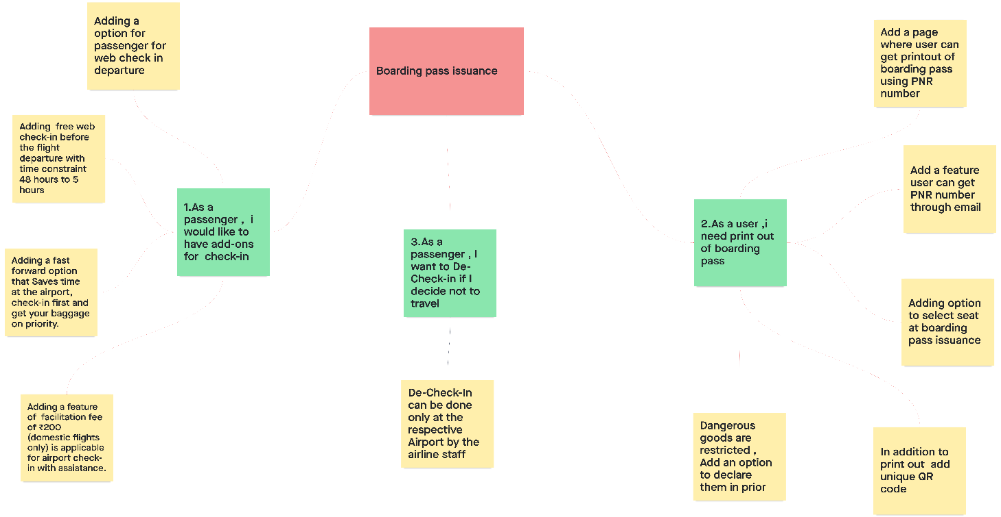

5. **Epic: *Select and order***

* Here the next important user Epic is Select and order. It is a complementary step where users can actually decide which food they want to eat during the journey on their flights.

**User stories:**

1. As a user, I would like to see how this food ordering website is useful for

passengers inside the plane.

i) Create a responsive page using HTML/CSS/JS

ii) Create a web page for finding different types of food providing in flights

iii) Create an account in that food ordering website and then login using those credentials.

iv) Now select the number and type of foods or drinks you want to be purchase.

v) Now select the date, time and passengers seat number for the food to be delivered and do the payment before entering into the flight.

vi) We will have online mode for ordering food because of these COVID situations and if any emergency uses, we will have offline service provided also.

2. As a User, I would like to view the various foods provided in the flight, so

that I can order them accordingly.

i) First add various options like snacks, main course, deserts, beverages and drinks.

ii) User should find maximum varieties of food in the menu that can be provided in a plane.

iii)Once we are done choosing the snack items, we should then navigate to another menu page.

iv) After that I should go to the drinks page, where I can find a good quality wine for my journey.

3. User needs to find what are all types of people, this food ordering web took into consideration.

i) If there is a senior – citizen in the plane we should provide some very soft rice for them to eat.

ii) If there is a pregnant woman in the plane, we should provide the suitable food for those woman.

iii) If there is a child of age between 1-3 years of age then we should provide some milk along with some calcium food.

iv) There should also be different fruit pieces and vegetable salads for the passengers.

v) If there is a veg / non-veg persons. They should be provided with their comfort of food.

vi) If there is a drunkard in the flight, we should provide him maximum availability of drinks.

4. User need to know how the payment process is done for the food ordering.

i) Firstly, we need to select all the items and put them in the cart. Then it will show you the total amount to be paid.

ii) Now we should select the name and type of the bank.

iii) Now we need to select the mode and method of paying the amount like debit / credit card and using UPI id’s etc.

iv) Now select the suitable mode and enter our pin and the transaction will be done.

v) If in case any transaction delays or any transaction failed messages are shown no need to worry those will be cleared within 1-2 days without any fail.

vi) User security is the ultimate priority for the company which will be safe without any fail.

5. User needs to know the quality of the food and for every item rating given by the users.

i) if we click on the item in the food section it should contain the ratings of that item given by the previous users.

ii) And we should show them the proof of quality like a certification or verification from the government.

iii) If in case of any uneatable and any pale food item found by the user. Then it will be taken out immediately and compensate with another food item.

iv) The water that is provided by us is very purified and mineral water which is good for drinking.

**Chart:**

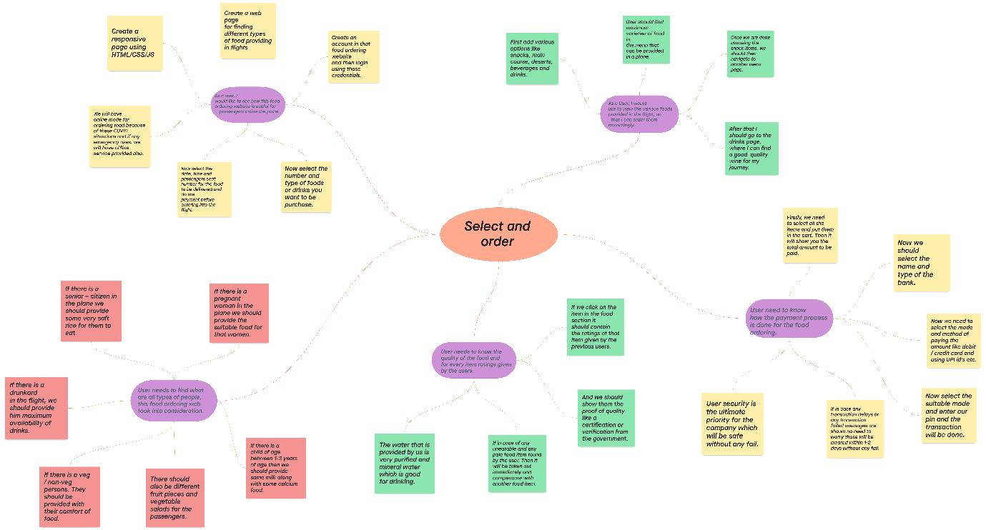

6. **Epic:** ***Ancillary services for my ticket*.**

**User Stories:**

1. As a user, I would like to add additional services for my journey.
   1. Add ‘ancillary booking’ button in ticket booking page.
   2. Add ‘text box’ to enter PNR number.
   3. Check available services from the drop-down list.
   4. Assign special service request (SSR) codes for each service.
   5. Add booking status to view the confirmation of the service
2. As a user, I would like to get brief description about services and view the pricing.
   1. Add drop down list to view the services.
   2. Display a brief description if you hover over a service name.
   3. Add a quantity box for each service.
   4. Display the maximum quantity for the services when you hover over the quantity box.
   5. Add a list view box to display prices for tiered services.
3. As a user, I would like filter ancillary services to a selected group code (type).
   1. Add filter arrow to display available services.
   2. Add a button to view the group codes.
   3. Display the services for each type.
   4. Display the services that is available for designated airlines.
4. As a user/flyer, I would like to enter additional remarks for required ancillary services.
   1. Add a free form text box to enter remarks.
   2. Add an ancillary drop down to select the service.
   3. Display the associate SSR of the applicable service.
   4. Add a ‘Store’ button to save the remarks.
   5. Add ‘Apply’ button to redisplay the list with remarks.
5. As a user, I would like to view/modify my ancillary booking.
   1. Add text box to enter PNR number.
   2. Enable retrieval of the PNR/booking file from DB.
   3. Add a shopping cart icon to display the availed services.
   4. Add modify button to change the services.
   5. Add confirm button to apply the changes

**Chart:**

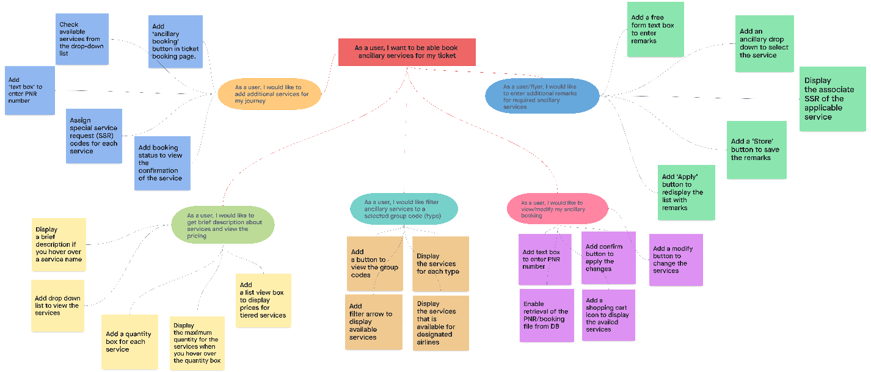

**Burndown Chart:**

